Singapore Package ( 42000 Per Person)

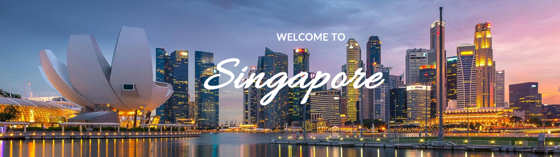
Day 1: Arrival Singapore Night Safari Tour
Greetings from Singapore You are met with our tour guide, who escorts you to the hotel and assists with the check-in. The rest of the day in leisure & spend the evening night tour Partake in a unique and exclusive evening experience at Night Safari. Kick start your journey with a guided tram ride traversing different zones that are home to some of the world’s most fascinating animals. Next, enter a secret lakeside location overlooking Upper Seletar Reservoir. and Overnight in Singapore.
Day 2: Singapore City Tour
Wake up to a late breakfast after a good rest and then commence on a two hour City Tour that will walk you through all the main attractions and landmarks of Singapore. The tour terminates back at the hotel for lunch. Relax and enjoy the luxurious amenities offered by the hotel. In the late afternoon, you will depart on a trip to the Sentosa Island for the remarkable Sentosa Underwater Tour. Here you can see the Merlion - the icon of Singapore and also visit the Underwater World. End the day with the magnificent and light show - Songs of the Sea before heading back to the hotel for the night. Stay overnight in Singapore.
Day 3: Universal Studio Singapore
After a delicious breakfast, you would be taken to Universal Studios. World Sentosa is home to some of Singapore’s leading attractions: Universal Studios Singapore (Southeast Asia’s first and only Universal Studios theme park)- Southeast Asia’s first Hollywood movie theme park, which brings the silver screen to life with its breathtaking rides, shows and enticing attractions based on some of the most popular movies and television series, such as: Ultimate 3D battle, Shrek 4-D Adventure, Revenge of the Mummy, Madagascar: A Crate Adventure and Battlestar Galactica among others.
Day 4: Singapore Sentosa
After a delicious breakfast and proceed to sentosa island, sea aquarium, wings of time.
Day 5: Departure
It's time to check out of the Hotel and be transferred to the Airport in time for you to connect your flight back home.
Call: +91 8569952715 for Booking
ENQUIRE NOW

